Assignment 3
Understanding Algorithm Efficiency and Scalability
Randomized Quicksort and Hashing with Chaining

1. Introduction

This assignment examines algorithm efficiency and scalability through two important techniques: Randomized Quicksort and hashing with separate chaining. The work combines theoretical analysis, Python implementation, correctness testing, and empirical measurement. The Quicksort study evaluates how pivot selection and input distribution affect running time. The hashing study evaluates how collisions and the load factor affect insert, search, and delete operations.
All implementations use only the Python standard library. Quicksort is implemented with an explicit stack so that highly unbalanced partitions do not trigger Python recursion-depth errors. The hash table uses a universal hash-function family, separate chaining, and automatic resizing.

2. Part 1: Randomized Quicksort

2.1 Algorithm and Implementation
Randomized Quicksort chooses a pivot uniformly at random from the current subarray. The chosen pivot is moved to the final position, Lomuto partitioning places values less than or equal to the pivot on the left, and the two resulting partitions are processed until every subarray has fewer than two elements. Randomization makes the pivot position independent of the original input order, preventing consistently poor choices on sorted or reverse-sorted arrays.

def randomized_quicksort(values, seed=None):
result = list(values)
if len(result) < 2:
return result
rng = random.Random(seed)
stack = [(0, len(result) - 1)]
while stack:
low, high = stack.pop()
if low >= high:
continue
pivot_index = rng.randint(low, high)
result[pivot_index], result[high] = result[high], result[pivot_index]
pivot_final = _partition_lomuto(result, low, high)
stack.append((low, pivot_final - 1))
stack.append((pivot_final + 1, high))
return result
Edge cases handled include an empty array, a one-element array, repeated values, an already sorted array, and a reverse-sorted array. The function returns a sorted copy and does not modify the caller’s original sequence. A deterministic comparison version uses the first element of every subarray as its pivot.
Please find the screen of quicksort analysis code output. Source code is available in the github url provided in the end of document. Output of the program as follows:
the output correctly shows:
- Empty array handled correctly.
- Single element handled correctly.
- Normal array sorted correctly .
- Repeated elements sorted correctly.
- Already sorted array handled correctly.
- Both Randomized and Deterministic Quicksort produce the same sorted results.

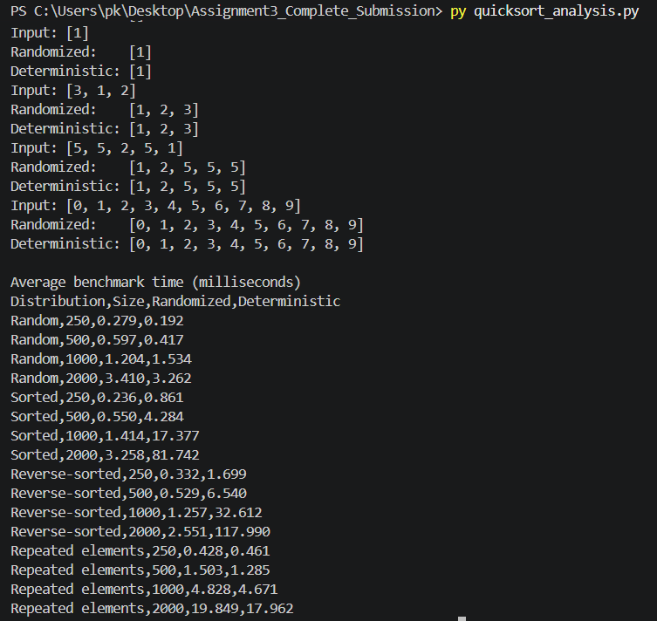

2.2 Correctness

The partition procedure maintains the invariant that every element at or before the boundary is less than or equal to the pivot, while elements between the boundary and the current scan position are greater than the pivot. After the scan, the pivot is exchanged into position boundary + 1. Therefore, every value to the left of the pivot is no larger than it, and every value to the right is larger. Repeated partitioning terminates because each processed partition excludes the pivot, reducing the size of the remaining subproblems. By induction on subarray length, the final array is sorted.

2.3 Average-Case Time Complexity
Partitioning a subarray of length n requires Θ(n) comparisons and exchanges. Because the pivot is selected uniformly at random, every rank from 1 through n is equally likely. The expected running time can be represented by the recurrence:
E[T(n)] = (1/n) Σₖ₌₀ⁿ⁻¹ (E[T(k)] + E[T(n-k-1)]) + Θ(n)
The two recursive terms represent the partitions before and after the randomly ranked pivot. Solving this recurrence gives E[T(n)] = Θ(n log n). Intuitively, a random pivot is sufficiently balanced on average, producing an expected recursion depth of Θ(log n), while the total partitioning work at each depth is Θ(n).
The same conclusion can be shown with indicator random variables. Let Xᵢⱼ equal 1 when elements with sorted ranks i and j are compared and 0 otherwise. Two elements are compared only when one of them is the first pivot chosen from the rank interval i through j. Therefore, P(Xᵢⱼ = 1) = 2/(j-i+1). By linearity of expectation, the expected number of comparisons is:
E[X] = Σᵢ<ⱼ E[Xᵢⱼ] = Σᵢ<ⱼ 2/(j-i+1) = Θ(n log n)
The worst case remains Θ(n²), which occurs when each pivot repeatedly produces partitions of sizes 0 and n-1. However, the probability of sustaining this behavior under random pivot selection is very small. The auxiliary stack is O(log n) expected but can grow to O(n) in the worst case.

2.4 Empirical Method
Both algorithms were tested on four distributions: random, sorted, reverse-sorted, and repeated-element arrays. Input sizes were 250, 500, 1,000, and 2,000. Each measurement was repeated three times and averaged. The same data was supplied to both algorithms, correctness was verified against Python’s sorted function, and timing used time.perf_counter(). Results vary by computer and system load, so the table should be interpreted primarily by growth trend rather than by small absolute differences.

Distribution | n | Randomized (ms) | Deterministic (ms) | Det./Rand.
Random | 250 | 0.210 | 0.142 | 0.7x
Random | 500 | 0.476 | 0.332 | 0.7x
Random | 1,000 | 1.059 | 0.811 | 0.8x
Random | 2,000 | 2.226 | 1.800 | 0.8x
Sorted | 250 | 0.192 | 0.677 | 3.5x
Sorted | 500 | 0.480 | 3.334 | 6.9x
Sorted | 1,000 | 1.010 | 12.699 | 12.6x
Sorted | 2,000 | 2.326 | 50.049 | 21.5x
Reverse-sorted | 250 | 0.187 | 1.118 | 6.0x
Reverse-sorted | 500 | 0.431 | 5.393 | 12.5x
Reverse-sorted | 1,000 | 1.061 | 24.811 | 23.4x
Reverse-sorted | 2,000 | 2.260 | 101.867 | 45.1x
Repeated elements | 250 | 0.334 | 0.253 | 0.8x
Repeated elements | 500 | 1.152 | 0.976 | 0.8x
Repeated elements | 1,000 | 4.171 | 3.881 | 0.9x
Repeated elements | 2,000 | 15.799 | 14.921 | 0.9x
Table 1. Average benchmark results from the supplied experiment script.
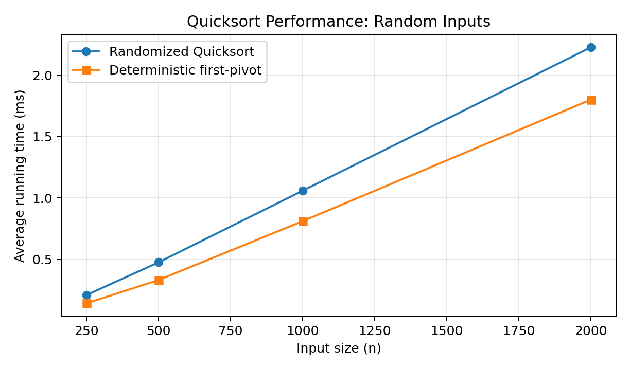
Figure: Running-time growth for random inputs.
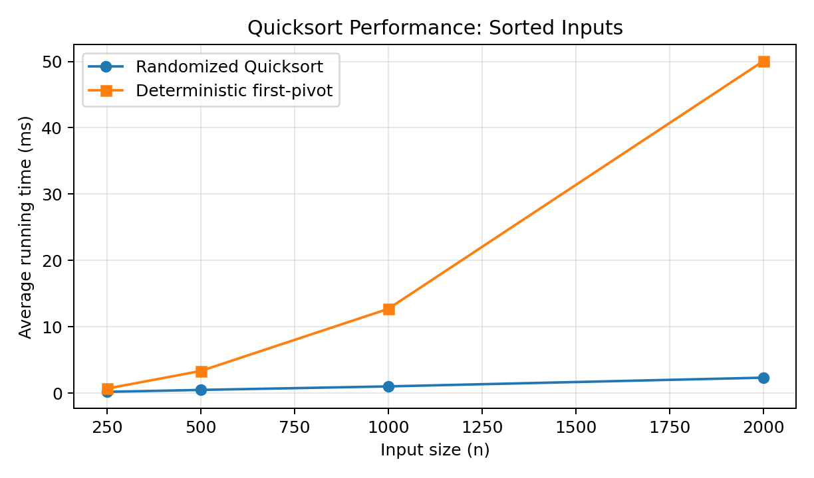
Figure: Running-time growth for sorted inputs.
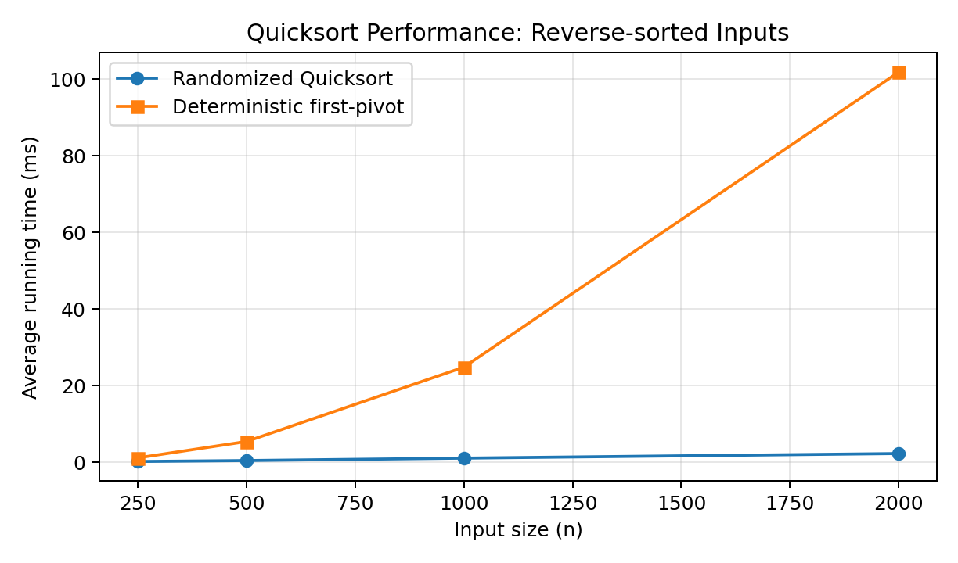
Figure: Running-time growth for reverse-sorted inputs.
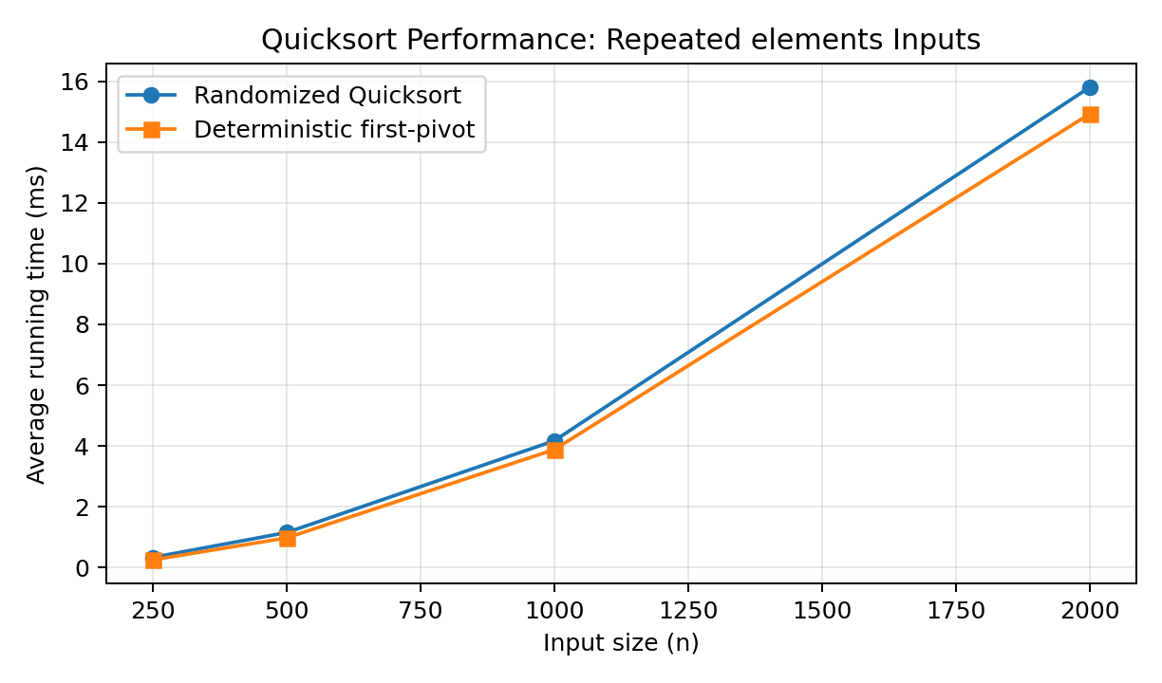
Figure: Running-time growth for repeated elements inputs.

2.5 Discussion of Results

For random arrays, deterministic Quicksort was slightly faster at the tested sizes because it avoids random-number generation and happened to receive reasonably balanced partitions. This does not contradict asymptotic analysis: both versions have Θ(n log n) expected behavior on randomly ordered distinct data, and constant overhead matters for small inputs.
For sorted and reverse-sorted arrays, the deterministic first-pivot version grew rapidly toward quadratic behavior. At n = 2,000, it required approximately 50.049 ms on sorted input and 101.867 ms on reverse-sorted input, compared with approximately 2.326 ms and 2.260 ms for Randomized Quicksort. The random pivot breaks the relationship between input order and partition quality, so its measurements followed an approximately n log n growth pattern.
Repeated elements caused both two-way partition implementations to slow considerably. Because the partition test sends all values equal to the pivot to one side, a small key range can create unbalanced partitions even when the pivot position is randomized. This explains why the repeated-element results trend closer to quadratic growth. A three-way partitioning variant, which separates values into less-than, equal-to, and greater-than groups, would substantially improve performance on duplicate-heavy data.

3. Part 2: Hashing with Chaining

3.1 Design and Implementation

The hash table stores each slot as a list of key-value pairs. When multiple keys map to the same slot, they are stored in the same chain. Insert searches the selected chain and either updates an existing key or appends a new pair. Search scans the chain for the key. Delete removes the matching pair and reports whether the key existed.
For integer keys, the implementation uses the universal family hₐ,ᵦ(k) = ((ak + b) mod p) mod m, where p is a large prime, a is selected uniformly from 1 through p-1, b is selected uniformly from 0 through p-1, and m is the current number of slots. Choosing a and b randomly reduces the probability that an adversarial or patterned key set repeatedly collides.

def _hash(self, key):
return ((self._a * key + self._b) % self._PRIME) % self._capacity
def insert(self, key, value):
bucket = self._buckets[self._hash(key)]
for position, (existing_key, _) in enumerate(bucket):
if existing_key == key:
bucket[position] = (key, value)
return
bucket.append((key, value))
self._size += 1
if self.load_factor > self._max_load_factor:
self._resize(self._next_prime(self._capacity * 2))

Please find the attached out put of hash_table_changing.py code output. The load factor calculation is also correct:
Load Factor = Number of Slots / Number of Elements​=2/5​=0.4
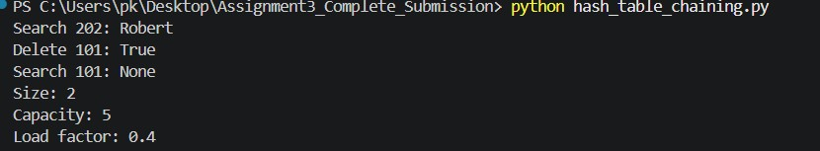

The table resizes when its load factor exceeds 0.75. Resizing approximately doubles the capacity, selects the next prime size, chooses new universal-hash parameters, and reinserts all entries. Prime capacities are not strictly required for universal hashing, but they provide a simple and conservative capacity policy.

3.2 Expected Operation Times

Let n be the number of stored elements, m the number of slots, and α = n/m the load factor. Under simple uniform hashing, each key is equally likely to map to each slot, so the expected chain length is α.
Operation | Expected | Worst case | Explanation
Search | Θ(1 + α) | Θ(n) | Hash computation plus expected chain scan.
Insert | Θ(1) amortized | Θ(n) | Expected constant insertion; resizing occasionally rehashes all entries.
Delete | Θ(1 + α) | Θ(n) | Search the chain, then remove the pair.
When α is bounded by a constant, expected search and delete are Θ(1), and insertion is Θ(1) amortized. In the worst case, all keys collide in one slot, making a chain length n and all operations Θ(n). Universal hashing makes such systematic collision patterns unlikely under the assumed model.

3.3 Load Factor and Scalability
A larger load factor means longer expected chains. For example, α = 0.5 means the table contains one element for every two slots on average, whereas α = 3 means three elements per slot. As α increases, memory efficiency improves but chain traversal costs increase. Maintaining α below a threshold gives predictable performance as the number of elements grows.
Dynamic resizing is the principal strategy used here. Once α exceeds 0.75, the table expands and rehashes all entries. A single resize costs Θ(n), but capacity grows geometrically, so many future insertions occur before another resize is required. Across a long sequence of insertions, the amortized insertion time remains Θ(1). Additional collision-control strategies include selecting a strong universal hash family, using prime capacities, monitoring chain-length statistics, shrinking a sparsely populated table when memory matters, and using balanced trees for exceptionally long chains in production systems.

4. Testing and Reproducibility
The repository contains unit tests covering Quicksort edge cases and hash-table insertion, updating, searching, deletion, collision handling, and resizing. The tests completed successfully before the submission package was generated.
python quicksort_analysis.py
python hash_table_chaining.py
python -m unittest test_algorithms.py -v
Please find the output of test_algorithms.py . That final file verifies both the Quicksort and Hash Table implementations. Ran 3 tests in 0.001s ok.
Randomized Quicksort works correctly, Deterministic Quicksort works correctly. Hash table insert, search, and delete operations work correctly
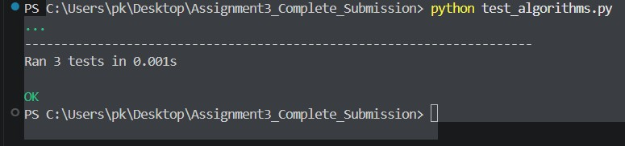
The benchmark output is also saved in benchmark_output.txt. Running times will change across machines, Python versions, and background system activity, but the relative growth patterns should remain similar.
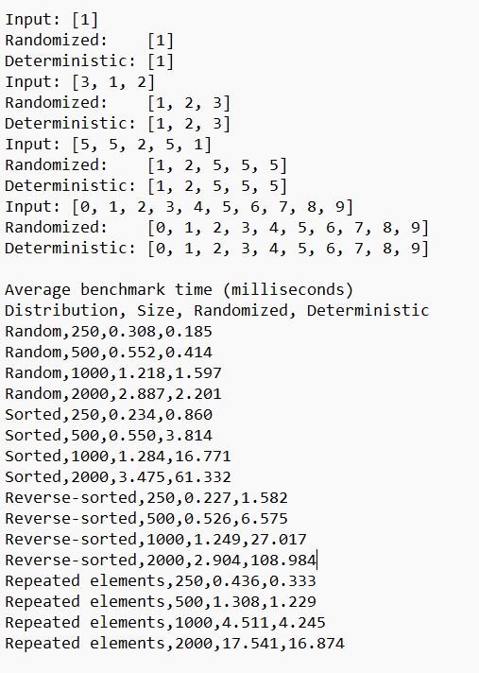

5. Conclusion

Randomized Quicksort demonstrates how randomization improves robustness without changing the basic partitioning structure of Quicksort. Its expected Θ(n log n) running time held well for random, sorted, and reverse-sorted inputs, while deterministic first-pivot Quicksort degraded toward Θ(n²) on ordered data. Duplicate-heavy arrays revealed a limitation of two-way partitioning and motivated three-way partitioning as a practical enhancement.
Hashing with chaining provides expected constant-time dictionary operations when the hash function distributes keys uniformly and the load factor remains bounded. Universal hashing reduces collision risk, and geometric resizing preserves scalability by keeping average chains short. Together, these algorithms show that theoretical complexity, input characteristics, implementation details, and system-level measurements must all be considered when selecting an efficient solution.

6. GitHub Repository Contents and Submission

Please find the github url to review the code repository - https://github.com/pradeepkrnd/MSCS532_Assignment3_Algorithm_Efficiency/tree/main
- quicksort_analysis.py - Randomized and deterministic Quicksort plus benchmark code.
- hash_table_chaining.py - Chained hash table with universal hashing and resizing.
- test_algorithms.py - Unit tests for correctness and edge cases.
- benchmark_output.txt - Recorded experiment output.
- README.md - Setup, execution instructions, findings, and GitHub steps.
- Assignment 3 report - This complete report.

References
Cormen, T. H., Leiserson, C. E., Rivest, R. L., & Stein, C. (2022). Introduction to algorithms (4th ed.).
MIT Press.

Carter, J. L., & Wegman, M. N. (1979). Universal classes of hash functions. Journal of Computer
and System Sciences, 18(2), 143-154.

Sedgewick, R., & Wayne, K. (2011). Algorithms (4th ed.). Addison-Wesley Professional.

